B615 – How to Check BCD Discount

Find discount amounts attached to a BCD number based on the rental location.

Mandatory Fields:

BCD: Enter BCD#
STA: 4/5-digit Maestro station number or 3-letter mnemonic code

Press Enter.

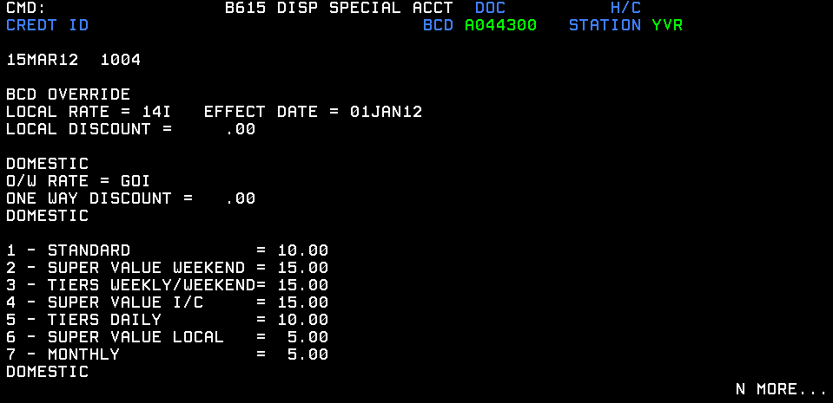

How to Read This Screen:

Let’s use the Federal Government BCD as an example – A044300. The BCD rate for this account is 14I. However, when the rack rates on budget.com are lower than the 14I, they will first be tethered before overriding the Federal Government rate.

Example 1:
On the day the reservation was made, A7I was $39/day as compared to the 14I rate of $49/day.

Since A7I has a lower rate, it is marked up and assigned a discount. The discount assigned will be a ‘Standard’ (number 1 in the image above) discount of 10% since it is a regular rental. When this reservation is delivered to GIS, it will have an AMI rate and a flex discount of 10%.
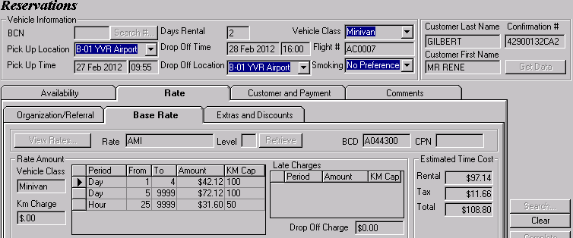

Example 2:
On the day the reservation was made, DBI was $155/week as compared to the 14I rate of $ 181.20/week.

Since DBI has a lower rate, it is marked up and assigned a discount. The discount assigned will be a ‘Tiers Weekly/Weekend’ (number 3 in the image above) discount of 15% since it is a weekly rental. When this reservation is delivered to GIS, it will have a DAI rate and a flex discount of 15%.

